Test Strategy Test Plan, and Test Techniques

Test Strategy

🧭 Definition
# Source: Chatgot (GPT-5-Standard) at [9/4/2025]
A test strategy is a high-level document (or section of a test plan) that describes how testing will be approached for a project or organization.
Think of it as the roadmap or policy — it doesn’t list individual test cases, but it defines the overall direction, scope, goals, and methods for testing.
It answers the big questions:
- What kind of testing will we do?
- What levels (unit, integration, system, acceptance) will we cover?
- What tools, techniques, and standards will we follow?
- What is “in scope” and “out of scope”?
- How will we measure success?
# Source: Chatgot (GPT-5-Standard) at [9/8/2025]
It means you decide how you will do the testing and what will be tested. This can include:
- Scope of testing: which features, modules, or components will be included or excluded.
- Types of testing to use: e.g., functional, performance, security, usability.
- Techniques: e.g., black-box, white-box, exploratory testing.
- Sequence or prioritization: which tests to run first or on which components.
- Resources and tools: what testing tools or environments you will use.
In short, the approach is your overall plan or method for performing the tests effectively within the defined scope.

🔹 Key Components of a Test Strategy
# Source: Chatgot (GPT-5-Standard) at [9/4/2025]
Most strategies (especially in ISTQB and industry practice) cover:
- Scope and Objectives
  - What will be tested, and what will not.
- Testing Types / Levels
  - Functional, non-functional (performance, security, usability, etc.).
  - Unit, integration, system, acceptance.
- Approach / Methodology
  - Manual vs automated testing.
  - Risk-based, exploratory, model-based, etc.
- Test Deliverables
  - What documents, reports, logs will be produced.
- Environment & Tools
  - Hardware, software, databases, networks, testing tools.
- Entry and Exit Criteria
  - Conditions for starting/stopping testing.
- Schedule & Resources
  - Who will test, when, and with what dependencies.
- Risk Management
  - How risks will be identified and mitigated in testing.
- Metrics and Reporting
  - How progress and quality will be measured (e.g., defect density, test coverage).

🔹 Purpose
# Source: Chatgot (GPT-5-Standard) at [9/4/2025]
- Provides consistency: all teams test in the same direction.
- Communicates the testing plan to stakeholders.
- Sets expectations: what quality level to aim for, what risks are accepted.
- Supports compliance: in regulated industries, a strategy is often mandatory.

💡 In simple terms:
# Source: Chatgot (GPT-5-Standard) at [9/4/2025]
- Test Plan = project-specific details (who, when, where).
- Test Strategy = organization/project-wide high-level policy (what, why, how in broad terms).

Sample Test Strategy Document
# Source: Chatgot (GPT-5-Standard) at [9/4/2025]
Excellent 👍 — let’s build this step by step: a full example of a Test Strategy document, so you can see exactly how it looks in practice.

🧭 Sample Test Strategy Document

1. Introduction
This document defines the test strategy for the Online Banking System (OBS) project.
It describes the overall testing approach, scope, objectives, and resources to ensure the product meets functional and non-functional requirements.

2. Scope & Objectives
- In Scope
  - Core banking features: Login, Account Management, Funds Transfer, Bill Payment.
  - Web and mobile platforms.
  - Functional, security, and performance testing.
- Out of Scope
  - Legacy modules (e.g., old reporting system).
  - Third-party integrations not updated in this release.
- Objectives
  - Validate that all functional requirements are met.
  - Verify security (authentication, authorization, encryption).
  - Ensure acceptable performance under expected load.

3. Test Levels & Types
- Levels
  - Unit Testing: Performed by developers.
  - Integration Testing: Validate APIs and data flow.
  - System Testing: Verify end-to-end features.
  - User Acceptance Testing (UAT): Final validation by business users.
- Types
  - Functional Testing: Positive, negative, boundary, and regression tests.
  - Non-Functional Testing:
    - Performance (load and stress testing).
    - Security (penetration testing, data privacy checks).
    - Usability testing on different devices/browsers.

4. Test Approach
- Combination of manual and automated testing:
  - Manual Testing: Exploratory, usability, ad-hoc checks.
  - Automated Testing: Regression suite for core functionalities using Selenium and JUnit.
- Risk-Based Prioritization:
  - High-risk modules (Funds Transfer, Login) tested first and more thoroughly.
- Defect tracking and reporting via JIRA.

5. Test Environment & Tools
- Environment
  - Web server: Apache Tomcat.
  - Database: Oracle 19c with test data.
  - Mobile testing: Android 12, iOS 16 devices.
  - Network: Simulated production bandwidth and security configuration.
- Tools
  - Test Management: TestRail.
  - Automation: Selenium WebDriver, JUnit.
  - Performance: JMeter.
  - Security: OWASP ZAP.

6. Entry & Exit Criteria
- Entry
  - All features implemented and unit tested.
  - Test environment ready.
  - Test data prepared.
- Exit
  - All critical and high defects fixed.
  - Test coverage ≥ 95% of defined test cases.
  - UAT sign-off received.

7. Deliverables
- Test plans for each cycle.
- Test cases and automation scripts.
- Daily and final test execution reports.
- Defect logs with severity and priority.
- Final test summary report.

8. Risks & Mitigation
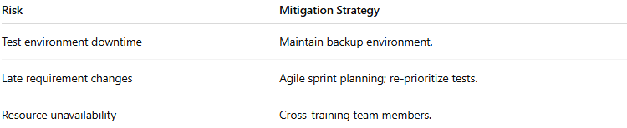
Risk | Mitigation Strategy
Test environment downtime | Maintain backup environment.
Late requirement changes | Agile sprint planning; re-prioritize tests.
Resource unavailability | Cross-training team members.

9. Schedule & Resources
- Test Cycle: 4 weeks (2 sprints).
- Team: 2 QA engineers (manual), 1 QA automation engineer, 1 performance tester.
- Reporting: Daily stand-ups, weekly status reports to project stakeholders.

10. Metrics & Reporting
- Test case execution progress (planned vs executed).
- Defect density per module.
- Test pass/fail rates.
- Automation coverage percentage.
- Mean time to defect detection.

This Test Strategy is reviewed and approved by the Project Manager, QA Lead, and Business Owner. It serves as a guiding document for all testing activities on the OBS project.

✅ This is a realistic, professional-style example — you can adapt it to any project by replacing the project name, scope, tools, and specific details.

real-world-inspired sample
# Source: Chatgot (GPT-5-Standard) at [9/4/2025]
Here’s a real-world-inspired sample of a Test Strategy document—not copied from a private or internal source, but based on authentic, publicly available references that reflect industry-standard structure and content:

Sample Test Strategy: E-Commerce Web Application
This example is adapted from publicly shared guidance, not a proprietary document, and illustrates how real testing strategies are structured.
Overview
- Product Name: E-Commerce Web Application
- Revision: v1.5
- Overview: An online e-commerce platform where users can browse products, add things to their cart, and complete secure purchases. Comprises a responsive web interface, a mobile app, backend systems, plus inventory and payment services.
(Katalon)

Product Background
- Previous Versions: v1.0, v1.2, v1.3
- Defect History: Previous issues included payment gateway integration failures and cart item retention errors. These were resolved via unit and integration testing, improving system reliability.
(Katalon)

Features to Be Tested
- User Features: Product search, cart functionality, user registration, checkout workflow.
- Layers:
  - Frontend: React.js
  - Backend: Node.js
  - Database: MySQL
  - API integrations
  - Mobile app flows and push notifications
- Non-functional Tests:
  - Performance: Stress testing up to 5,000 concurrent users using JMeter
  - Security: Vulnerability scanning using OWASP ZAP
(Katalon)

Entry Criteria (System Test)
- Core functionality (search, login, cart) must be functional.
- All unit tests must pass successfully.
- Code freeze in place; latest build available in the repository.
- All known issues logged in the defect tracking system.
(Katalon)

Exit Criteria (System Test)
- All planned system tests executed.
- All happy-path scenarios (e.g., user registration, product purchase) pass.
- A working build is available for all supported platforms.
- No critical (showstopper) defects remain.
- Maximum thresholds: ≤5 major bugs, ≤10 minor bugs.
(Katalon)

Deliverables
- Test plans (system, regression, performance).
- Documented test cases in tools like Jira or TestRail.
- Execution logs of all tests.
- Defect reports hosted in the bug-tracking system.
- Coverage reports showing percentage of features/code tested.
(Katalon)

Metrics & Targets
- Test Coverage: Aim for 95% across unit, integration, and system tests.
- Defect Density: Maintain less than 1 defect per 1,000 lines of code.
- Performance Target: Ensure key transactions respond within 2 seconds.
- Defect Leakage: Keep production leakage under 2%.
(Katalon)

Risks
- Instability of payment gateway under high load.
- Cross-browser inconsistencies, especially in older browsers.
- Degraded performance with >5,000 concurrent users.
- Potential security vulnerabilities introduced by new authentication features.
(Katalon)

References
- Internal API documentation
- Selenium and JMeter setup guides
- OWASP standards for security testing
(Katalon)

Summary
This real example reflects the structure and content found in genuine organizational test strategies: inclusive of scope, planned tests, quality metrics, tools, and risk management. It’s based on practical patterns widely taught and used in the industry.
Would you like a similarly detailed Agile-style test strategy example or an annotated template based on this structure?

Test Plan

📝 Definition
# Source: Chatgot (GPT-5-Standard) at [9/4/2025]
A Test Plan is a formal document that describes what, how, when, and who will test a software product.
It acts like a roadmap for testing — guiding the QA team and communicating with stakeholders.

🎯 Purpose of a Test Plan
# Source: Chatgot (GPT-5-Standard) at [9/4/2025]
- To define the scope of testing (what will and will not be tested).
- To describe the testing approach (manual, automated, tools).
- To set schedules and responsibilities.
- To identify risks and how to mitigate them.
- To align QA with business and project goals.

🧩 Typical Components (based on IEEE 829 / ISTQB)
# Source: Chatgot (GPT-5-Standard) at [9/4/2025]
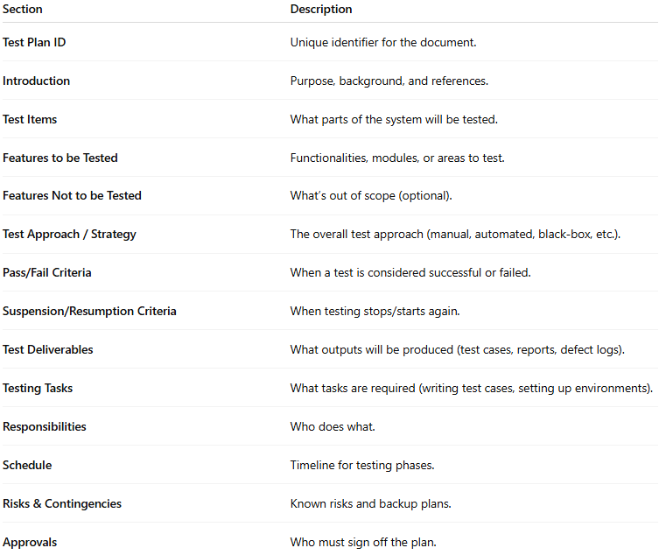
Section | Description
Test Plan ID | Unique identifier for the document.
Introduction | Purpose, background, and references.
Test Items | What parts of the system will be tested.
Features to be Tested | Functionalities, modules, or areas to test.
Features Not to be Tested | What’s out of scope (optional).
Test Approach / Strategy | The overall test approach (manual, automated, black-box, etc.).
Pass/Fail Criteria | When a test is considered successful or failed.
Suspension/Resumption Criteria | When testing stops/starts again.
Test Deliverables | What outputs will be produced (test cases, reports, defect logs).
Testing Tasks | What tasks are required (writing test cases, setting up environments).
Responsibilities | Who does what.
Schedule | Timeline for testing phases.
Risks & Contingencies | Known risks and backup plans.
Approvals | Who must sign off the plan.

🖥️ Example (simplified)
# Source: Chatgot (GPT-5-Standard) at [9/4/2025]
Project: Online Shopping App
Version: 1.0
Prepared by: QA Team
- Introduction:
Testing the checkout and payment modules of the Online Shopping App.
- Scope:
Test the following modules: Cart, Checkout, Payment, Order Confirmation.
Out of scope: Admin backend.
- Approach:
  - Manual functional testing (black-box techniques: EP, BVA).
  - Automated regression testing using Selenium.
  - Risk-based prioritization.
- Environment:
Test environment mirrors production: Windows Server, MySQL, Payment Gateway Sandbox.
- Schedule:
  - Test case design: July 1–5
  - Test execution: July 6–15
  - Bug fix verification: July 16–20
- Responsibilities:
  - QA Lead: Approve test plan, monitor progress.
  - QA Engineers: Write & execute test cases.
  - Developers: Fix defects.
- Risks:
  - Payment gateway downtime may delay testing.
  - Limited test data for some scenarios.
- Deliverables:
  - Test cases, test execution reports, defect logs, final test summary report.
- Approval:
Signed by Project Manager, QA Lead.

Is Test Strategy is same test plan?
# Source: Chatgot (GPT-5-Standard) at [9/4/2025]
Excellent follow-up 👏 — this is where many people get confused.
Short answer: ❌ No — a Test Strategy is not the same as a Test Plan. They are related, but different in purpose, scope, and level.

🧭 Difference between Test Strategy & Test Plan
# Source: Chatgot (GPT-5-Standard) at [9/4/2025]
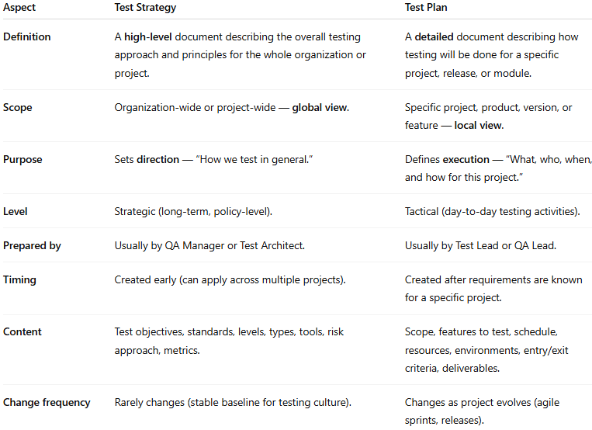
Aspect | Test Strategy | Test Plan
Definition | A high-level document describing the overall testing approach and principles for the whole organization or project. | A detailed document describing how testing will be done for a specific project, release, or module.
Scope | Organization-wide or project-wide — global view. | Specific project, product, version, or feature — local view.
Purpose | Sets direction — “How we test in general.” | Defines execution — “What, who, when, and how for this project.”
Level | Strategic (long-term, policy-level). | Tactical (day-to-day testing activities).
Prepared by | Usually by QA Manager or Test Architect. | Usually by Test Lead or QA Lead.
Timing | Created early (can apply across multiple projects). | Created after requirements are known for a specific project.
Content | Test objectives, standards, levels, types, tools, risk approach, metrics. | Scope, features to test, schedule, resources, environments, entry/exit criteria, deliverables.
Change frequency | Rarely changes (stable baseline for testing culture). | Changes as project evolves (agile sprints, releases).

🖥️ Example relationship:
# Source: Chatgot (GPT-5-Standard) at [9/4/2025]
- Test Strategy:
"All company projects will use risk-based testing, automated regression, and mandatory security testing following ISO standards."
- Test Plan (for Online Shopping App v1.0):
"We will test checkout and payment modules manually using black-box techniques, and run automated regression on the login and cart modules using Selenium."

💡 Think of it this way:
# Source: Chatgot (GPT-5-Standard) at [9/4/2025]
- Test Strategy = Company / Organization / Project-wide policy → like the “testing constitution.”
- Test Plan = Project-specific roadmap → like a “mission plan” for this version or release.

Summary
# Source: Chatgot (GPT-5-Standard) at [9/4/2025]
💡 In short: A test plan is the master plan for how testing will be done — it ensures everyone is aligned and nothing important is forgotten.

Test Techniques
# Source: Chatgot (GPT-5-Standard) at [9/4/2025]

🧪 Definition
# Source: Chatgot (GPT-5-Standard) at [9/4/2025]
A test technique is a method used to design test cases.
In other words: it’s how you decide what inputs, conditions, and data to use when testing a system.
It’s about systematically selecting a set of tests that have a good chance of finding defects — without testing every single possible input (which is impossible).

🔹 Why They Matter
# Source: Chatgot (GPT-5-Standard) at [9/4/2025]
- They increase coverage (more of the system is checked).
- They reduce effort (fewer but smarter tests).
- They make testing measurable (you can define coverage criteria).

🔹 Main Categories of Test Techniques
# Source: Chatgot (GPT-5-Standard) at [9/4/2025]
There are three broad groups (ISTQB standard):
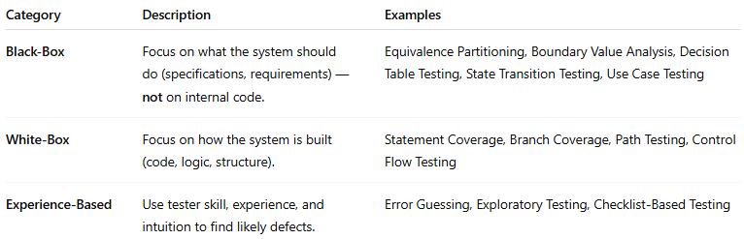
Category | Description | Examples
Black-Box | Focus on what the system should do (specifications, requirements) — not on internal code. | Equivalence Partitioning, Boundary Value Analysis, Decision Table Testing, State Transition Testing, Use Case Testing
White-Box | Focus on how the system is built (code, logic, structure). | Statement Coverage, Branch Coverage, Path Testing, Control Flow Testing
Experience-Based | Use tester skill, experience, and intuition to find likely defects. | Error Guessing, Exploratory Testing, Checklist-Based Testing

🖤 Black-Box Test Techniques (examples)
# Source: Chatgot (GPT-5-Standard) at [9/4/2025]
- Equivalence Partitioning (EP)
Divide input data into groups (“partitions”) where all values are expected to behave the same — then test just one from each group.
Example: Age input (1–120) → partitions: <1 (invalid), 1–120 (valid), >120 (invalid).
- Boundary Value Analysis (BVA)
Test at the edges of input ranges, where errors are common.
Example: If age is valid from 18–60 → test 17, 18, 60, 61.
- Decision Table Testing
Use a table of conditions and actions to make sure all combinations are tested.
Example: Login success/failure based on username, password, account status.
- State Transition Testing
Test how the system moves between states.
Example: ATM → Idle → Card Inserted → PIN Entered → Transaction → Idle.
- Use Case Testing
Design tests based on user journeys or scenarios.

🤍 White-Box Test Techniques (examples)
# Source: Chatgot (GPT-5-Standard) at [9/4/2025]
- Statement Coverage — Make sure every line of code runs at least once.
- Branch Coverage — Ensure every decision (true/false) is executed at least once.
- Path Coverage — Execute all possible paths through a piece of code.
- Loop Testing — Test loops with zero, one, and many iterations.

🧠 Experience-Based Test Techniques (examples)
# Source: Chatgot (GPT-5-Standard) at [9/4/2025]
- Error Guessing — Guess where defects might be based on experience (e.g., null inputs, special characters).
- Exploratory Testing — Simultaneous learning, test design, and execution.
- Checklist-Based Testing — Use known problem checklists (e.g., security, accessibility).

💡 In short:
# Source: Chatgot (GPT-5-Standard) at [9/4/2025]
- Test techniques are tools in a tester’s toolkit to design better, smarter tests.
- You don’t have to use only one — professional testing usually combines several techniques.

💡 Summary:
# Source: Chatgot (GPT-5-Standard) at [9/4/2025]
- Test Strategy → High-level approach: overall goals, scope, and direction of testing.
- Test Plan → Project-specific document: detailed schedule, tasks, resources, and deliverables for testing.
- Test Techniques → Practical methods: how to design test cases.

